Content

Organisation overview. Page 2
Problem overview. Page 2
User groups. Page 3
Empathy maps. Page 3
user stories. Page 4
laws, guidance and legislation. Page 5
alternative systems. Page 6
risks. Page 7
decomposition. Page 8
User acceptance. Page 11
functional and non-functional. Page 12
scope. Page 13
key performance indicators. Page 15
proposed solution. Page 16

Organisation Overview

I have been tasked to develop a digital solution for Greenfield Local Hub (GLH). GLH is a cooperative of local farmers and food producers. GLH offers: a single location retail outlet for locally produced food and drink, collective marketing for local farmers and food producers, product management, stock control and product traceability.

GLH (the client) would like to develop a digital solution that will:
Provide information about the producers, their methods and the benefits of buying locally.

Allow customers to:
view products with transparent pricing and availability, place orders for collection or delivery, manage their accounts and view order history.

Provide a dashboard to enable producers to manage stock levels, update product details and view orders.

The client has conducted market research with existing customers to identify features that could be included in the digital solution. The features suggested by the client are: order management, scheduling and tracking features, a loyalty scheme that provides discounts and special offers, accessibility features to support a wide range of users.

Problem Overview

GLH wishes to modernise its operations and expand it’s reach, however, the current digital solution GLH has is non-existent, or it just lacks necessary features the website GLH are requesting has, either way, they can’t manage orders, or provide producers with a means to sell to customers online, making it hard for them to have a chance in this competitive market.

Issues:
There is limited information available for customers about producers and their backgrounds, which prevents informed purchasing decisions.
Customers lack an easy way to view products, check pricing, and place orders.
The lack of an order management system makes it difficult for producers to track orders, manage stock levels, and update product details effectively.
Scheduling and tracking of orders seem to be non-existent online, making it hard to manage, leading to potential customer dissatisfaction.
Customers do not have a user-friendly interface to manage their accounts, view order history, or access loyalty programs.
The lack of accessibility features prevents a diverse range of users, including those with disabilities, from accessing the platform.

User Groups

Producers:
the users who will be selling the products, they will be: managing stock levels, product details and will also view orders.
Age 18-65 – age of workers in the UK, some could be apprentices and others could be workers reaching retirement

customers:
age 18-70 – users of technology, the platform should target a large consumer base who are interested in local produce

Admin:
age 18-65 – similar with producers in that this could be apprentices or workers reaching retirement.

Empathy maps

Producer
Says  I need to manage my stock without lots of difficulty.  I want my customers to understand where my food comes from.  I want to know about new orders that come in. | Thinks  Is stock data accurate and up to date for customers?  Customers will value their products more if they know about farming methods and origin.  I need to make sure I don’t miss and order.
Does  Updates product details, prices and stock levels.  Adds information about farming methods and sourcing.  Checks the dashboard regularly. | Feels  Frustrated by slow or clunky interfaces.  Happy that their methods can easily be recognised by customers.  Concerned about missing an order as it could lead to unhappy customers.

Customers
Says  I’d like to have a quick way to order for pickup or delivery.  I want to know where my food comes from.  I’d like loyalty rewards and easy checkout. | Thinks  Will my delivery/pickup be on time?  Is this producer trustworthy and sustainable?  Is my personal data safe on checkout?
Does  Places order for pickup or delivery.  Reads producer info, checks pricing and availability.  Pays for order. | Feels  Anxious about missing deliveries.  Unsure when information is vague and hard to understand.  Satisfied with smooth checkout and loyalty rewards feature.

Admin
Says  I need clear audit trails and data analytics.  I need to make sure everything is running smoothly.  We need accurate stock and order management. | Thinks  Will the system scale with more producers and orders?  How can I support customers and producers better?  If stock levels and orders aren’t tracked properly, it could cause confusion for producers and customers.
Does  Monitors analytic, audits data, manages roles/permissions.  Monitors for any performance issues.  Monitors system dashboard, checks stock levels and manages orders. | Feels  Frustrated by lack of data analytics.  Responsible for any issues (or lack thereof) that users are having.  Stressed if any errors occur.

User Stories
As a | I want | So that | Acceptance criteria
Customer | To place orders for collection or delivery | I can access these products conveniently | Add both collection and delivery option to order
Customer | To manage my account | I can make sure all my information is correct | Allow users
Customer | To receive rewards through a loyalty scheme | I can save money on products I want to buy | Include a loyalty scheme in the website
Customer | To know why I should by local | I feel good about the impact I make when I buy local | Include information on why buying local is beneficial
Producer | To manage my stock | Customer’s can see accurate information | Allow producers to manage their stock
producer | To view orders | I can fulfil them efficiently | Producers can see list of orders
producer | To share information about my production methods and origin | Customers understand the benefits of buying local | Producers can enter production details for each product and customers can clearly read this info before making a purchase
Admin | To manage user accounts | I can make sure the system is secure and accurate | Admins can add edit or remove accounts, admins can reset passwords or update permissions, admins can also view user activity
admin | Monitor all orders and stock levels | I can ensure there are no stock issues | Admins can view and manage all orders and stock
admin | To manage promotions. | I can gain Customer engagement | Admins can manage promotions, customers can see promotions applied to their account, promotions are applied automatically at checkout.

Laws, Guidance and Legislation

Data Protection Act (DPA) and UK General Data Protection Regulation (GDPR) – this controls how GLH will collect store and use personal data,
Impact:
- I can only collect necessary personal data (like name email and address)
- System must include a privacy policy explaining how data is used
- Customers must be able to access, update, or request deletion of data
- Data must be stored securely to prevent breaches (I will use access levels on the database so that only admins may view user details)
Equality act 2010 – protects people from discrimination and ensures services are accessible to all users, including those with disabilities.
Impact:
- Website must include accessibility features (screen readers, clear navigation adjustable text size, good colour contrast)
- Ensure those with visual, hearing or physical impairments can use the platform
Consumer rights act 2015 – protects customers when they buy goods online
Impact:
- Products must be accurately described
- Pricing must be clear and transparent
- Customers must have clear information about delivery, refunds and returns
- The system must show accurate stock availability to avoid misleading customers
Copyright, Designs and patents act 1988 – protects creative content like images text logos and branding
Impact:
- The site cannot use images or text without permissions or licences
- Producers must upload their own product images or authorised media
- GLH must ensure no copyrighted material is used illegally
Privacy and electronic communications regulations (PECR) – Rules about electronic marketing and cookies
Impact:
- The site must have a cookie consent banner.
- Users must opt in to marketing emails or promotions
- Users must be able to unsubscribe from said emails and promotions

Alternative systems

https://www.amazon.co.uk
amazon is the most successful e-commerce platform, so therefore it should have the best usability, performance and customer experience.
pros:
- an advanced search and filtering system
- personalised recommendations
- order tracking
- customer reviews and ratings
cons:
- lack of focus on local companies
- little amount of transparency on product sourcing
- feels overly commercial
FarmDrop – Online Farmers Market With Local Pickup and Delivery
similar concept to GLH making it a relevant system to analyse
pros:
- direct connection between farmers and customers
- transparency about sourcing
- ethical branding
cons:
- struggles with availability and costs, the UK versions has been shut down
- delivery options can be restricted
- producers have less control over how products are marketed/sold than GLH intends

risks
difference between client expectations and delivered features – this will be mitigated by regular client reviews
lack of accessibility for users with disabilities – include colour contrast and large readable text
complex ordering system so users will not finish ordering items – simplify checkout, provide guest flow.
Personal data breaches/exposure of payment information – encryption, privilege levels, security audits
Non compliance with data protection laws and consumer rights – data mapping, clear consent management and data retention policies.

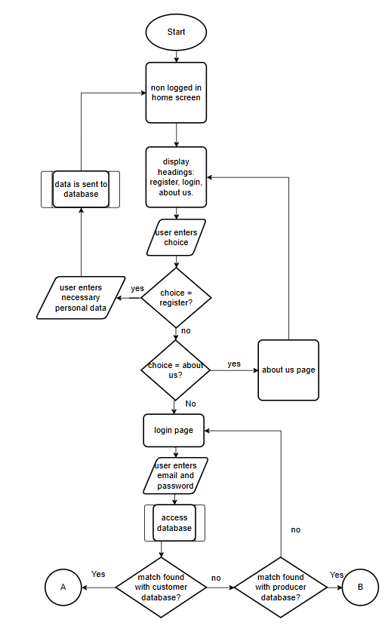
Decomposition

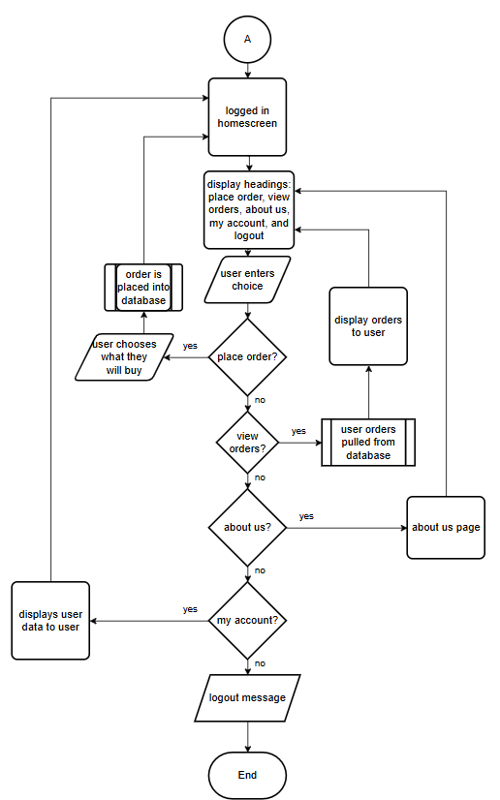
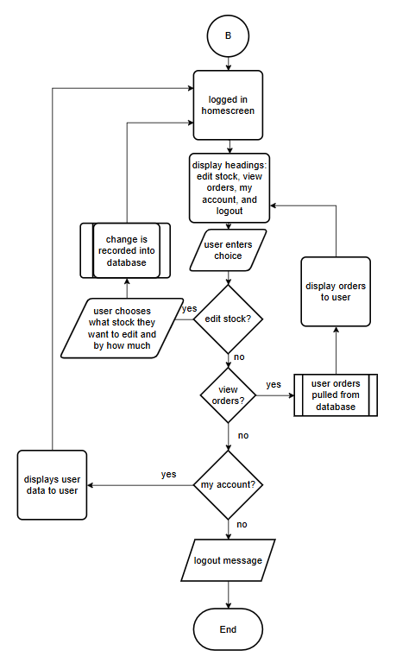

User Acceptance Criteria
- Accessibility and Usability:
  - system is accessible on desktop with a responsive layout
  - all pages meet WCAG 2.2 AA criteria for accessibility
  - colours are contrasting so that page is more readable
  - visual indicators for interactive elements, e.g. visual outline around buttons
  - error messages are clear and descriptive
- Customer functionality
  - customers can view all products with price, availability and description displayed
  - customers can add items to cart, update quantities and remove items
  - customers can place orders for delivery or pickup
  - customers can choose delivery address
  - customers can track orders
  - customers can use the loyalty scheme
- Producer functionality
  - producers can view their dashboard
  - producers can add, update or remove products
  - producers can view and manage incoming orders
  - producers can update availability in real time
  - producers can see analytics of their products
- System and security
  - all user actions generate audit logs
  - all transactions are securely processed
  - system loads pages in under 3 seconds
  - system had uptime of at least 99%

Functional and Non-Functional Requirements
FR
- Customers:
  - can see the price of an item
  - add items to cart and modify quantity
  - choose delivery or location options along with available time slots
  - schedule recurring orders
  - choose a delivery location
  - cancel orders within an allowed window
  - view order history
- Producers:
  - create, edit and remove products
  - manage stock levels
  - view incoming orders
  - set or adjust prices
- Admin
  - create/manage user accounts, and assign roles and permissions to accounts
  - manage and reschedule orders
  - create/manage loyalty programs
  - log audit trails
- System
  - users can register and log in
  - passwords are processed securely using encryption
  - response times should be kept under a second
  - provide accessible UI compatible with WCAG
  - navigation bar will be displayed to all users

NFR

- Performance
  - website will load pages within 3 seconds
  - website will support multiple users at a time
- security
  - user data will be stored securely
  - the system will use a secure login authentication
  - the website will comply with UK GDPA and DPA 2018
- usability
  - the website will be easy to navigate and user-friendly
  - product info will be clear and easy to understand
  - users should be able to complete orders with minimal steps
- accessibility
  - the website will be accessible to users with disabilities
  - it will follow accessibility guidelines (good colour contrast and screen reader compatibility)
  - compliance with the equality act 2010
- reliability
  - available most of the time with minimal downtime
  - orders and data should not be lost if an error occurs

Scope
The scope for the project will be:
even if a user isn’t logged in they can view information about the producers and the benefits of buying locally.
users can create accounts, login into those accounts and will be assigned a role – customer or Producer.
Customers can then:
- view products with pricing included
- place orders for collection or delivery
- manage accounts and order history
Producers can then:
- manage stock
- update product details
- view orders
What I wont do
these features may have been mentioned in this document already, this is because these would be included in a fully fleshed out project where it would be possible to add all of these ideas.
- Accessing payment details – this will be too complicated for this scale of project, email and text notifications, as this will also be out of scale.
- Real-time tracking – as there is no way to test it as there is nothing to actually track.
- Give refunds – I have no idea how I will handle that system without payment details.
- Include a functional company email as this will be GLH’s job to manage, this also includes marketing emails and cookies
- Properly calculate delivery time. Each delivery will only take up one timeslot no matter where the delivery is to, this is because this feature is also out of scale.
- Special sales/discounts, as this feature is not necessary and not worth including, producers will just have to change price normally.
- Compatibility with other devices – this will be hard to test since we’ll only be using desktops, I also don’t think this would fit in my time-frame.
- Privacy policy – This is something that GLH should handle as I am not a legal expert but a programmer.
- Follow copyright laws – GLH has not provided me with any company images to use so I might use a copyright image. However, I will be trying to avoid copyright images but I cannot guarantee that the site will be copyright free.
- Mark orders as completed or missed, whilst orders can be rescheduled I think it would be out of scope to put order statuses down as I think there are more important features I should include.

Key Performance Indicators
- customer interaction:
  - new customers per month
  - activation rate - % of registered users who place first order within first month
  - repeat purchase rate - % of customers with two+ purchases within a certain time frame
  - average order value – total revenue/number of orders
  - cart abandon rate - % of started orders abandoned
  - order conversion rate – orders completed / sessions to checkout
- feedback:
  - customer satisfaction rate – percentage of users who give website 4-5 stars
  - improved online reviews – average rating of reviews over time
  - net promoter score – how likely customers are to recommend website to others
  - complaint rate – how many complaints does the website get per week
- performance
  - page load time – time it takes page to fully load
  - downtime – amount of time the website is unavailable
  - error rate – percentage of system errors (failed transactions/broken pages)
  - performance as number of users increase
  - number of security incidents
  - transaction process time
- sales
  - total revenue per month – measuring overall financial success of the platform
  - revenue growth rate – tracking the expansion of the financial success
  - revenue per user – tracking how valuable each user is
  - sales per week – indicates how often users order from the website
- producer interaction
  - number of active producers – how many producers upload/update products per month
  - producer retention rate - % of producers that continue to use the platform over time
  - stock accuracy rate - % of stock correctly marked as in/out of stock

Proposed Solution
Above I have been setting up the requirements for the system, this section will be my summary of the proposal and it’s benefits to the client – GLH.
Key features and benefits:
- The website will be an inclusive platform that will allow all users to navigate through and use it’s functionality. This means clear navigation, readable text sizes, colour contrast etc will be included. GLH will ensure all users feel included and therefore satisfied with the platform, making it more likely for users to come back if they find the website easy to use.
- The website will promote the benefits from buying from local producers, displaying their methods and reasons why users should support these producers. This will educate the customers so that they GLH can build trust and loyalty with these customers.
- Users will be able to create user accounts that will have their data stored securely using encryption on passwords and using access levels on the database itself, this will prevent data breaches, which would cause the company to lose trust and reputation, heavily damaging GLH as a company
- The website will also have quick and easy ordering feature that allows customers to choose whether they want to collect their order of have it delivered to them. Making the ordering process smooth, easy and convenient will improve customer satisfaction and make it more likely for customers to order again.
- the website will allow producers to fully control their products and the information displayed on their page, this will ensure information is up to date, also improving the relations between GLH and it’s producers as producers can ensure their information (availability, pricing, descriptions) is correct and prevent any issues like under/overselling or any incorrect stock levels.

